Here is an example of a page that is working:
https://www.lrsd.net/page/50958/4-1-safe-modern-accessible-spaces
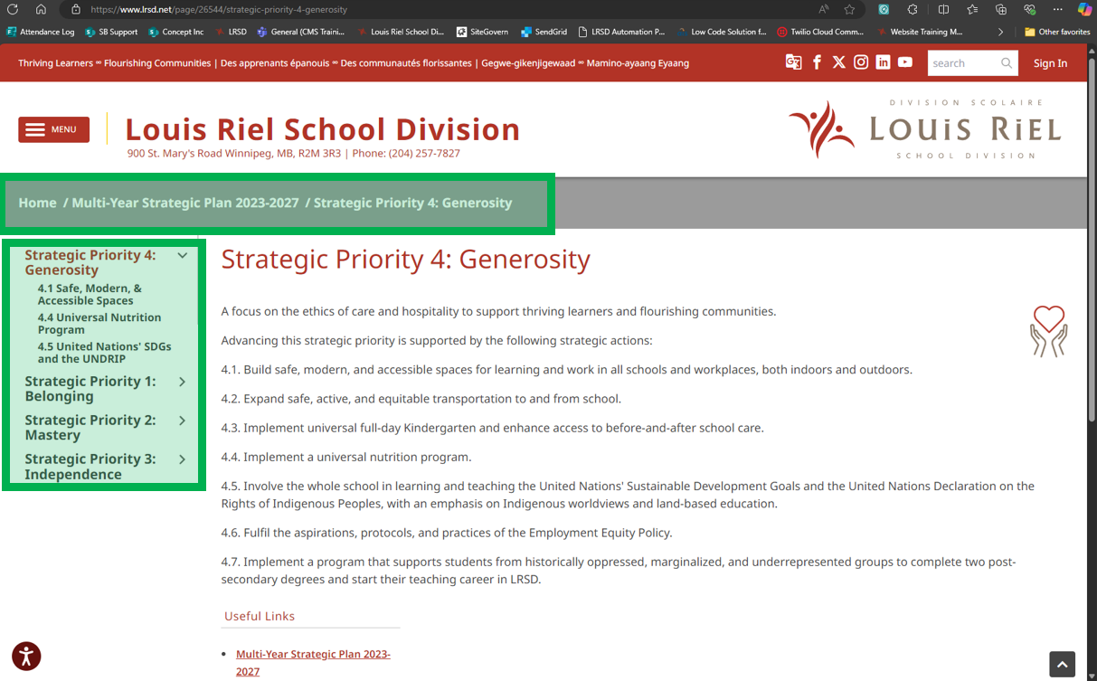
You can see that the breadcrumbs are showing at the top of the page (Home / Multi-Year Strategic Plan 2023-2027 / Strategic Priority 4: Generosity) and you can see that the navigation on the left is in context to the page that we’re currently on.

This page was having problems though:
https://www.lrsd.net/page/51215/45-united-nations-sdgs-and-the-undrip
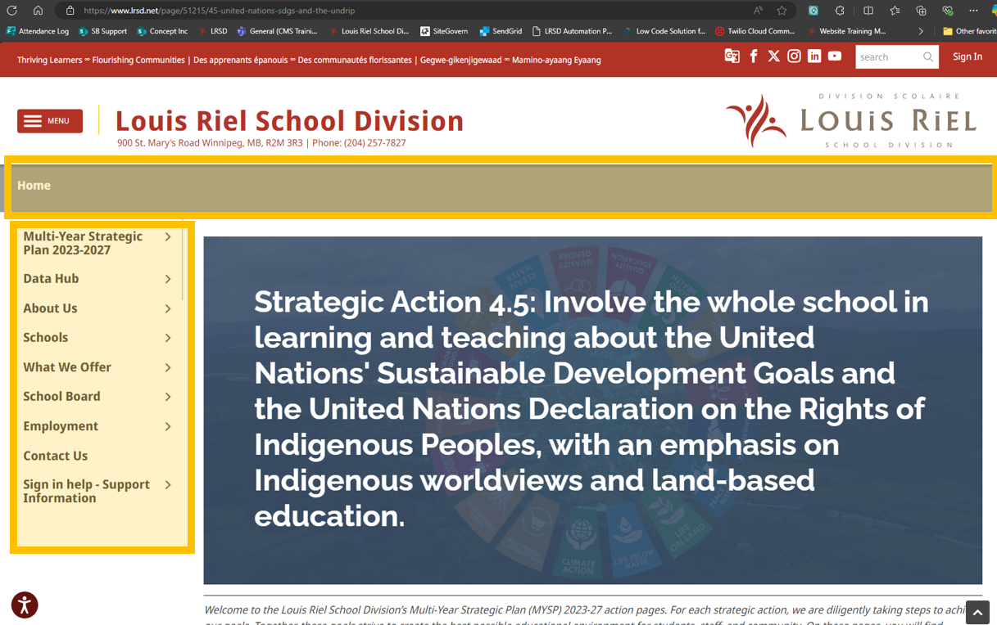
The breadcrumbs are missing. The left hand navigation is only showing the top level navigation and is not in context to where the page is. The problem appears to be the title of the page “4.5 United Nations' SDGs and the UNDRIP” when we remove the apostrophe, the display starts working again.

Can you please update the site so that apostrophes in the page title do not break the navigation?

